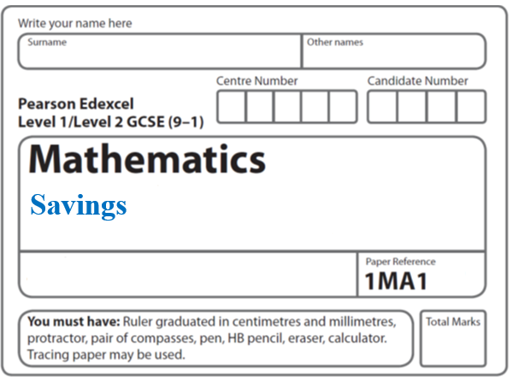**Instructions**

**Compound interest**

* Use **black** ink or ball-point pen.
  + **Fill in the boxes** at the top of this page with your name,  
    centre number and candidate number.
* Answer **all** questions.
* Answer the questions in the spaces provided  
  *– there may be more space than you need.*
* You must **show all your working.**
* Diagrams are **NOT** accurately drawn, unless otherwise indicated.
* If your calculator does not have a *π* button, take the value of *π* to be3.142

unless the question instructs otherwise.

**Information**

* The total mark for this paper is **34**. There are **9** questions.
* Questions have been arranged in an ascending order of mean difficulty, as found by all students in the June 2017–November 2019 examinations.
* The marks for **each** question are shown in brackets  
  *– use this as a guide as to how much time to spend on each question.*

**Advice**

* Read each question carefully before you start to answer it.
* Keep an eye on the time.
* Try to answer every question.
* Check your answers if you have time at the end.

**1** Anil wants to invest £25 000 for 3 years in a bank.

|  |  |  |
| --- | --- | --- |
| **Personal Bank** |  | **Secure Bank** |
| Compound Interest |  | Compound Interest |
| 2% for each year |  | 4.3% for the first year |
|  |  | 0.9% for each extra year |

Which bank will give Anil the most interest at the end of 3 years?

You must show all your working.

**(Total for Question 1 is 3 marks)**

**___________________________________________________________________________**

**2** Katy invests £200 000 in a savings account for 4 years.

The account pays compound interest at a rate of 1.5 % per annum.

Calculate the total amount of interest Katy will get at the end of 4 years.

£.......................................................

**(Total for Question 2 is 3 marks)**

**___________________________________________________________________________**

**3** Jean invests £12 000 in an account paying compound interest for 2 years.

In the first year the rate of interest is *x*%

At the end of the first year the value of Jean’s investment is £12 336

In the second year the rate of interest is %

What is the value of Jean’s investment at the end of 2 years?

£......................................................

(**Total for Question 3 is 4 marks**)

**___________________________________________________________________________**

**4** Marie invests £8000 in an account for one year.

At the end of the year, interest is added to her account.

Marie pays tax on this interest at a rate of 20%

She pays £28.80 tax.

Work out the percentage interest rate for the account.

....................................................... %

**(Total for Question 4 is 3 marks)**

**___________________________________________________________________________**

**5** Sakira invested £3550 in a savings account for 3 years.

She was paid 2.6% per annum compound interest for each of the first 2 years.

She was paid *R*% interest for the third year.

Sakira had £3819.21 in her savings account at the end of the 3 years.

Work out the value of *R*.

Give your answer correct to 1 decimal place.

.......................................................

**(Total for Question 5 is 3 marks)**

**___________________________________________________________________________**

**6** Northern Bank has two types of account.

Both accounts pay compound interest.

|  |  |  |
| --- | --- | --- |
| **Cash savings account**  Interest  2.5% per annum |  | **Shares account**  Interest  3.5% per annum |

Ali invests £2000 in the cash savings account.

Ben invests £1600 in the shares account.

(*a*)Work out who will get the most interest by the end of 3 years.

You must show all your working.

**(4)**

In the 3rd year the rate of interest for the shares account is changed to 4% per annum.

(*b*)Does this affect who will get the most interest by the end of 3 years?

Give a reason for your answer.

......................................................................................................................................................

......................................................................................................................................................

......................................................................................................................................................

**(1)**

**(Total for Question 6 is 5 marks)**

**___________________________________________________________________________**

**7** Jack bought a new boat for £12 500.

The value, £*V*, of Jack’s boat at the end of *n* years is given by the formula

*V* = 12 500 × (0.85)*n*

(*a*)At the end of how many years was the value of Jack’s boat first less than 50% of the

value of the boat when it was new?

.......................................................

**(2)**

A savings account pays interest at a rate of *R*% per year.

Jack invests £5500 in the account for one year.

At the end of the year, Jack pays tax on the interest at a rate of 40%.

After paying tax, he gets £79.20.

(*b*)Work out the value of *R*.

.......................................................

**(3)**

**(Total for Question 7 is 5 marks)**

**___________________________________________________________________________**

**8** The number of fish in a lake decreases by *x* % each year.

Given that the number of fish halves in 8 years, work out the value of *x*.

Give your answer correct to 1 decimal place.

.......................................................

**(Total for Question 8 is 3 marks)**

**___________________________________________________________________________**

**9** Natasha pays £13 995 for a car.

Lauren pays £14 495 for a car.

Assume that

the rate of depreciation for Natasha’s car is 12% per annum

and the rate of depreciation for Lauren’s car is 13% per annum.

(a) Work out whose car will have the greater value at the end of 3 years?

You must show all your working.

**(4)**

The rate of depreciation assumed for Natasha’s car was too low.

(b) How does this affect the value of her car at the end of 3 years?

......................................................................................................................................................

......................................................................................................................................................

**(1)**

**(Total for Question 9 is 5 marks)**

**TOTAL MARKS FOR PAPER: 34**