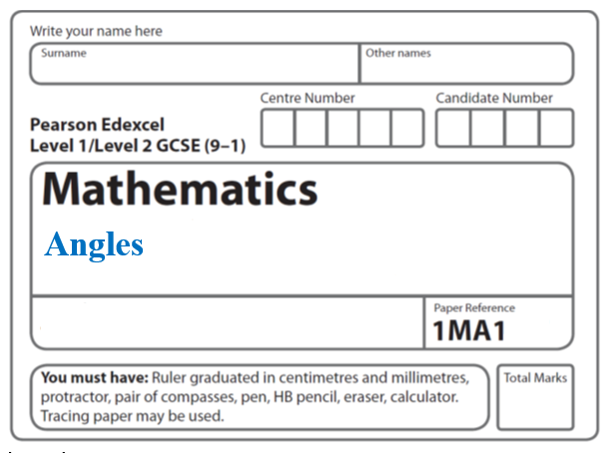

**Angles Proof**

**Instructions**

* Use **black** ink or ball-point pen.
  + **Fill in the boxes** at the top of this page with your name,  
    centre number and candidate number.
* Answer **all** questions.
* Answer the questions in the spaces provided  
  *– there may be more space than you need.*
* You must **show all your working.**
* Diagrams are **NOT** accurately drawn, unless otherwise indicated.
* If your calculator does not have a *π* button, take the value of *π* to be3.142

unless the question instructs otherwise.

**Information**

* The total mark for this paper is **21**. There are **5** questions.
* Questions have been arranged in an ascending order of mean difficulty, as found by all students in the June 2017–November 2019 examinations.
* The marks for **each** question are shown in brackets  
  *– use this as a guide as to how much time to spend on each question.*

**Advice**

* Read each question carefully before you start to answer it.
* Keep an eye on the time.
* Try to answer every question.
* Check your answers if you have time at the end.

**1**

**

*ABCD* is a parallelogram.

*EDC* is a straight line.

*F* is the point on *AD* so that *BFE* is a straight line.

Angle *EFD* = 35°

Angle *DCB* = 75°

Show that angle *ABF* = 70°

Give a reason for each stage of your working.

**(Total for Question 1 is 4 marks)**

**___________________________________________________________________________**

**2** *ABCD* is a quadrilateral.

**

*AB* = *CD*.

Angle *ABC* = angle *BCD*.

Prove that *AC* = *BD*.

**(Total for Question 2 is 4 marks)**

**___________________________________________________________________________**

**3**

**

*ABCD* is a parallelogram.

*ABP* and *QDC* are straight lines.

Angle *ADP* = angle *CBQ* = 90°

(*a*)Prove that triangle *ADP* is congruent to triangle *CBQ*.

(**3**)

(*b*)Explain why *AQ* is parallel to *PC*.

(**2**)

(**Total for Question 3 is 5 marks**)

**____________________________________________________________________________**

**4**



The diagram shows three right-angled triangles.

Prove that **

**(Total for Question 4 is 4 marks)**

**___________________________________________________________________________**

**5**



In the diagram *ABC* and *DEFG* are parallel lines.

Angle *ABE* = *x*°

*EB* = *EF*

Show that *w* = 90 + *x*

Give a reason for each stage of your working.

**(Total for Question 5 is 4 marks)**

**___________________________________________________________________________**

**TOTAL MARKS FOR PAPER: 21**