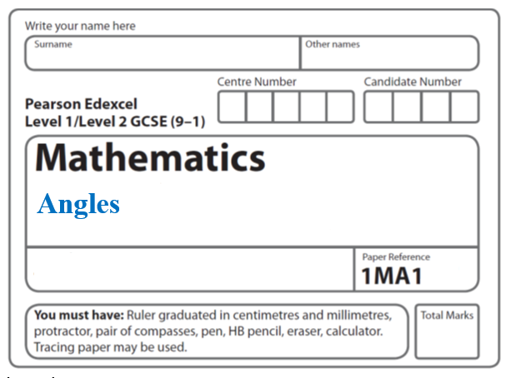

**Instructions**

* Use **black** ink or ball-point pen.
  + **Fill in the boxes** at the top of this page with your name,  
    centre number and candidate number.
* Answer **all** questions.
* Answer the questions in the spaces provided  
  *– there may be more space than you need.*
* You must **show all your working.**
* Diagrams are **NOT** accurately drawn, unless otherwise indicated.
* If your calculator does not have a *π* button, take the value of *π* to be3.142

unless the question instructs otherwise.

**Information**

* The total mark for this paper is **22**. There are **5** questions.
* Questions have been arranged in an ascending order of mean difficulty, as found by all students in the June 2017–November 2019 examinations.
* The marks for **each** question are shown in brackets  
  *– use this as a guide as to how much time to spend on each question.*

**Advice**

* Read each question carefully before you start to answer it.
* Keep an eye on the time.
* Try to answer every question.
* Check your answers if you have time at the end.

**1** *ABCDE* is a pentagon.

**

Angle *BCD* = 2 × angle *ABC*

Work out the size of angle *BCD*.

You must show all your working.

....................................................... °

(**Total for Question 1 is 5 marks**)

**___________________________________________________________________________**

**2** The diagram shows a hexagon.

The hexagon has one line of symmetry.

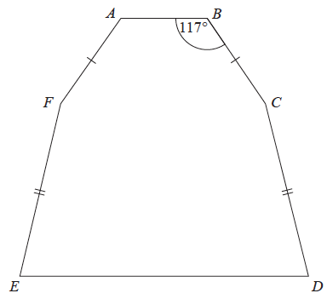

*FA* = *BC*

*EF* = *CD*

Angle *ABC* = 117°

Angle *BCD* = 2 × angle *CDE*

Work out the size of angle *AFE*.

You must show all your working.

.......................................................°

**(Total for Question 2 is 4 marks)**

**___________________________________________________________________________**

**3** The diagram shows triangle *ABC*.

**

*ADB* is a straight line.

the size of angle *DCB* : the size of angle *ACD* = 2 : 1

Work out the size of angle *BDC*.

....................................................... °

**(Total for Question 3 is 4 marks)**

**___________________________________________________________________________**

**4** *BEG* is a triangle.



*ABC* and *DEF* are parallel lines.

Work out the size of angle *x*.

Give a reason for each stage of your working.

.......................................................°

**(Total for Question 4 is 4 marks)**

**___________________________________________________________________________**

**5**



*ABC* and *DEF* are parallel straight lines.

*ABE* is an isosceles triangle with *AB* = *BE*.

Angle *CBE* = 142°

Work out the size of angle *x*.

Give a reason for each stage in your working.

.........................................°

**(Total for Question 5 is 5 marks)**

**___________________________________________________________________________**

**TOTAL MARKS FOR PAPER: 21**