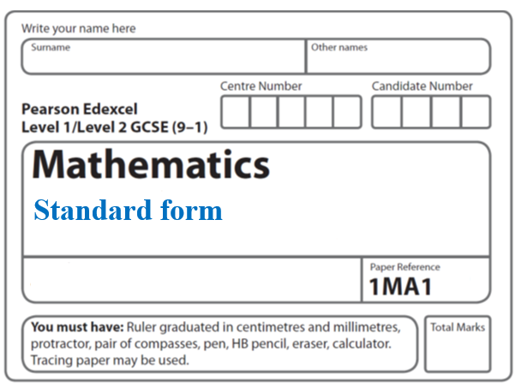

**Instructions**

* Use **black** ink or ball-point pen.
  + **Fill in the boxes** at the top of this page with your name,  
    centre number and candidate number.
* Answer **all** questions.
* Answer the questions in the spaces provided  
  *– there may be more space than you need.*
* You must **show all your working.**
* Diagrams are **NOT** accurately drawn, unless otherwise indicated.
* If your calculator does not have a *π* button, take the value of *π* to be3.142

unless the question instructs otherwise.

**Information**

* The total mark for this paper is **42**. There are **14** questions.
* Questions have been arranged in an ascending order of mean difficulty, as found by all students in the June 2017–November 2019 examinations.
* The marks for **each** question are shown in brackets  
  *– use this as a guide as to how much time to spend on each question.*

**Advice**

* Read each question carefully before you start to answer it.
* Keep an eye on the time.
* Try to answer every question.
* Check your answers if you have time at the end.

**1** (*a*)Write 0.00562 in standard form.

.......................................................

**(1)**

(*b*)Write 1.452 × 103 as an ordinary number.

.......................................................

**(1)**

**(Total for Question 1 is 2 marks)**

**___________________________________________________________________________**

**2** Write the following numbers in order of size.

Start with the smallest number.

0.045 × 103 4.5 × 10–3 450 0.45 × 10–1

......................................................................................................................................................

**(Total for Question 2 is 2 marks) ___________________________________________________________________________**

**3** In May 2019, the distance between Earth and Mars was 3.9 × 107 km.

In May 2019, a signal was sent from Earth to Mars.

Assuming that the signal sent from Earth to Mars travelled at a speed of 3 × 105 km per second,

(*a*)how long did the signal take to get to Mars?

....................................................... seconds

**(2)**

The speed of the signal sent from Earth to Mars in May 2019 was actually less than

3 × 105 km per second.

(*b*)How will this affect your answer to part (*a*)?

......................................................................................................................................................

......................................................................................................................................................

......................................................................................................................................................

**(1)**

**(Total for Question 3 is 3 marks)**

**___________________________________________________________________________**

**4** Work out (3.42 × 10−7) ÷ (7.5 × 10−6)

Give your answer in standard form.

.......................................................

**(Total for Question 4 is 2 marks)**

**___________________________________________________________________________**

**5** (a) Write 3.6 × 104 as an ordinary number.

.......................................................

**(1)**

(b)Work out the value of (2.8 × 10–2) ÷ (4.7 × 105)

Give your answer in standard form correct to 3 significant figures.

.......................................................

**(2)**

**(Total for Question 5 is 3 marks)**

**___________________________________________________________________________**

**6** (*a*)Write 32 460 000 in standard form.

.......................................................

**(1)**

(*b*)Write 4.96 × 10−3 as an ordinary number.

.......................................................

**(1)**

Asma was asked to compare the following two numbers.

*A* = 6.212 × 108 and *B* = 4.73 × 109

She says,

“6.212 is bigger than 4.73 so *A* is bigger than *B*.”

(*c*)Is Asma correct?

You must give a reason for your answer.

......................................................................................................................................................

......................................................................................................................................................

......................................................................................................................................................

**(1)**

**(Total for Question 6 is 3 marks)**

**___________________________________________________________________________**

**7** Work out (13.8 × 107) × (5.4 × 10−12)

Give your answer as an ordinary number.

.......................................................

**(Total for Question 7 is 2 marks)**

**___________________________________________________________________________**

**8** (*a*)Write the number 0.000 086 23 in standard form.

..............................................................

**(1)**

(*b*)Work out 

Give your answer in standard form, correct to 3 significant figures.

..............................................................

**(2)**

**(Total for Question 8 is 3 marks)**

**___________________________________________________________________________**

**9** Find the value of 

Give your answer correct to 1 decimal place.

.......................................................

**(Total for Question 9 is 2 marks)**

**___________________________________________________________________________**

**10** The table shows some information about eight planets.

|  |  |  |
| --- | --- | --- |
| **Planet** | **Distance from Earth (km)** | **Mass (kg)** |
| Earth | 0 | 5.97 × 1024 |
| Jupiter | 6.29 × 108 | 1.898 × 1027 |
| Mars | 7.83 × 107 | 6.42 × 1023 |
| Mercury | 9.17 × 107 | 3.302 × 1023 |
| Neptune | 4.35 × 109 | 1.024 × 1026 |
| Saturn | 1.28 × 109 | 5.68 × 1026 |
| Uranus | 2.72 × 109 | 8.683 × 1025 |
| Venus | 4.14 × 107 | 4.869 × 1024 |

(*a*)Write down the name of the planet with the greatest mass.

......................................................

**(1)**

(*b*)Find the difference between the mass of Venus and the mass of Mercury.

...................................................... kg

**(1)**

Nishat says that Neptune is over a hundred times further away from Earth than Venus is.

(*c*)Is Nishat right?

You must show how you get your answer.

**(2)**

**(Total for Question 10 is 4 marks)**

**___________________________________________________________________________**

**11** (*a*)Write 7.97 × 10−6 as an ordinary number.

.......................................................

**(1)**

(*b*)Work out the value of (2.52 × 105) ÷ (4 × 10−3)

Give your answer in standard form.

.......................................................

**(2)**

**(Total for Question 11 is 3 marks)**

**___________________________________________________________________________**

**12** (a) Write 1.04 × 105 as an ordinary number.

.......................................................

**(1)**

(b) Write 0.06 in standard form.

.......................................................

**(1)**

4.62 × 108 tins of beans were sold last year.

These tins of beans cost a total of £300.3 million.

(c) Work out the average cost per tin of beans.

£.......................................................

**(2)**

**(Total for Question 12 is 4 marks)**

**___________________________________________________________________________**

**13** (*a*) Write 0.005 49 in standard form.

..................................................................................

**(1)**

(*b*) Find the value of (8 × 103)2

Give your answer in standard form.

..................................................................................

**(2)**

(*c*)Find the value of (7.6 × 105) + (8.7 × 104)

Give your answer in standard form.

..................................................................................

**(2)**

**(Total for Question 13 is 5 marks)**

**___________________________________________________________________________**

**14** The distance from the Earth to the Sun is 1.496 × 1011 metres.

The speed of light is 3 × 108 metres per second.

(a) Show that, correct to 3 significant figures, light will take 0.139 hours to travel from the Sun to the Earth.

**(3)**

1 googol is 1 × 10100

Danesh says,

When I multiply 1.496 × 1011 by 6.68 × 109

I get nearly 1 googol because 1.496 × 1011 × 6.68 × 109 = 9.99 × 1099

Is Danesh correct?

(b) Give a reason for your answer.

......................................................................................................................................................

......................................................................................................................................................

**(1)**

**(Total for Question 14 is 4 marks)**

**___________________________________________________________________________**

**TOTAL FOR THIS PAPER: 42**