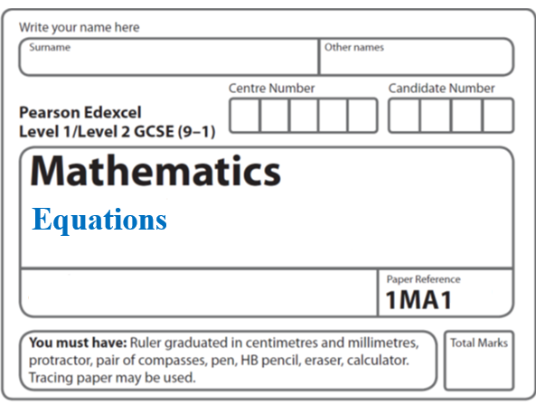**Instructions**

**Algebraic Fractions**

* Use **black** ink or ball-point pen.
  + **Fill in the boxes** at the top of this page with your name,  
    centre number and candidate number.
* Answer **all** questions.
* Answer the questions in the spaces provided  
  *– there may be more space than you need.*
* You must **show all your working.**
* Diagrams are **NOT** accurately drawn, unless otherwise indicated.
* If your calculator does not have a *π* button, take the value of *π* to be3.142

unless the question instructs otherwise.

**Information**

* The total mark for this paper is **49**. There are **14** questions.
* Questions have been arranged in an ascending order of mean difficulty, as found by all students in the June 2017–November 2019 examinations.
* The marks for **each** question are shown in brackets  
  *– use this as a guide as to how much time to spend on each question.*

**Advice**

* Read each question carefully before you start to answer it.
* Keep an eye on the time.
* Try to answer every question.
* Check your answers if you have time at the end.

**1** Simplify 

.......................................................

**(3)**

**(Total for Question 1 is 6 marks)**

**___________________________________________________________________________**

**2** Simplify fully 

.......................................................

(**Total for Question 2 is 3 marks**)

**___________________________________________________________________________**

**3** Simplify fully 

..................................................................................

**(3)**

**(Total for Question 3 is 3 marks)**

**___________________________________________________________________________**

**4** Show that  can be written in the form  where *a*, *b*, *c* and *d* are integers.

**(Total for Question 15 is 3 marks)**

**___________________________________________________________________________**

**5** Solve 

*x* = ......................................................

**(Total for Question 5 is 4 marks)**

**___________________________________________________________________________**

**6** Show that 6 +  simplifies to where *a*, *b*, *c* and *d* are integers.

**(Total for Question 6 is 4 marks)**

**___________________________________________________________________________**

**7** Write  as a single fraction in its simplest form.

..............................................................................................................

**(2)**

**(Total for Question 7 is 2 marks)**

**___________________________________________________________________________**

**8 ** can be written as a single fraction in the form **

where *a* and *b* are integers.

Work out the value of *a* and the value of *b.*

*a =* ......................................................

*b =* ......................................................

**(Total for Question 8 is 4 marks)**

**___________________________________________________________________________**

**9** Write  –  as a single fraction in its simplest form.

.......................................................

**(Total for Question 9 is 4 marks)**

**___________________________________________________________________________**

**10** (*a*)Write  in the form  where *a*, *b*, *c* and *d* are integers.

..............................................................

**(3)**

(*b*)Express  as a single fraction in its simplest form.

..............................................................

**(3)**

**(Total for Question 10 is 6 marks)**

**___________________________________________________________________________**

**11** Show that  ÷  simplifies to  where *a*, *b* and *c* are integers.

**(3)**

**(Total for Question 11 is 5 marks)**

**___________________________________________________________________________**

**12** Show that  simplifies to a*x* where a is an integer.

**(Total for Question 12 is 4 marks)**

**___________________________________________________________________________**

**13** Show that  can be written as 

**(Total for Question 13 is 2 marks)**

**___________________________________________________________________________**

**14** Write 

as a single fraction in its simplest form.

You must show your working.

......................................................

**(Total for Question 14 is 4 marks)**

**TOTAL MARKS FOR PAPER: 49**