**GCSE Mathematics**

**Practice Tests: Set 14**

**Paper 2H/3H (Calculator)**

**Time: 1 hour 30 minutes**

You should have: Ruler graduated in centimetres and millimetres, protractor, pair of compasses, pen, HB pencil, eraser, calculator. Tracing paper may be used.

**Instructions**

* Use **black** ink or ball-point pen.
* **Fill in the boxes** at the top of this page with your name,  
  centre number and candidate number.
* Answer **all** questions.
* Answer the questions in the spaces provided



– *there may be more space than you need*.

* **Calculators may not be used.**
* Diagrams are NOT accurately drawn, unless otherwise indicated.
* You must **show all your working out.**

**Information**

* The total mark for this paper is 80
* The marks for **each** question are shown in brackets  
  – *use this as a guide as to how much time to spend on each question*.

**Advice**

* Read each question carefully before you start to answer it.
* Keep an eye on the time.
* Try to answer every question.
* Check your answers if you have time at the end.

**Answer ALL questions.**

**Write your answers in the spaces provided.**

**You must write down all the stages in your working.**

**1**The diagram shows a right-angled triangle.

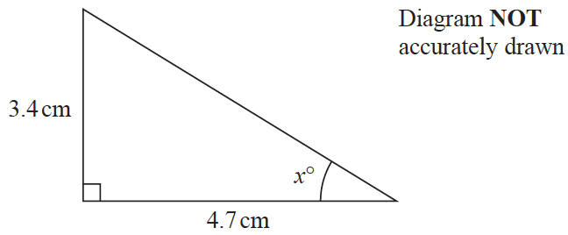

Calculate the value of *x*.

Give your answer correct to one decimal place.

*x* = .......................................................

**(Total for Question 1 is 3 marks)**

**___________________________________________________________________________**

**2**Himari’s annual salary is 3 130 000 Japanese Yen (JPY).

She gets a salary increase of 4%

(*a*) Work out Himari’s salary after this increase.

.......................................................JPY

**(3)**

Kaito bought a car.

The value of the car when Kaito bought it was 750 000 JPY.

At the end of each year, the value of his car had depreciated by 15%

(*b*)Work out the value of Kaito’s car at the end of 3 years.

Give your answer correct to the nearest JPY.

....................................................... JPY

**(3)**

**(Total for Question 2 is 6 marks)**

**___________________________________________________________________________**

**3**The table shows information about the lengths of time, in minutes, 120 customers spent

in a supermarket.

|  |  |
| --- | --- |
| **Lengthoftime(*L* minutes)** | **Frequency** |
| 20 < *L* ≤ 30 | 6 |
| 30 < *L* ≤ 40 | 26 |
| 40 < *L* ≤ 50 | 31 |
| 50 < *L* ≤ 60 | 40 |
| 60 < *L* ≤ 70 | 17 |

(*a*)Write down the modal class.

.......................................................

**(1)**

(*b*)Work out an estimate for the mean length of time spent by the 120 customers in the

supermarket.

.......................................................minutes

**(4)**

**(Total for Question 3 is 5 marks)**

**___________________________________________________________________________**

**4** In a sale, normal prices are reduced by 20%

A designer handbag costs £1080 in the sale.

Work out the normal price of the bag.

£.......................................................

**(Total for Question 4 is 3 marks)**

**___________________________________________________________________________**

**5**The diagram shows an isosceles triangle.



Work out the area of the triangle.

.......................................................cm2

**(Total for Question 5 is 4 marks)**

**___________________________________________________________________________**

**6** Here is a list of six numbers written in order of size.

|  |  |  |  |  |  |
| --- | --- | --- | --- | --- | --- |
| 4 | 7 | *x* | 10 | *y* | *y* |

The numbers have

a median of 9

a mean of 11

Find the value of *x* and the value of *y*.

*x* = .......................................................

*y* = .......................................................

**(Total for Question 6 is 4 marks)**

**___________________________________________________________________________**

**7**The diagram shows a solid cylinder with radius 3 m.



The volume of the cylinder is 72*π* m3

Calculate the **total**surface area of the cylinder.

Give your answer correct to 3 significant figures.

.......................................................m2

**(Total for Question 7 is 5 marks)**

**___________________________________________________________________________**

**8** Here is a 10-sided polygon.

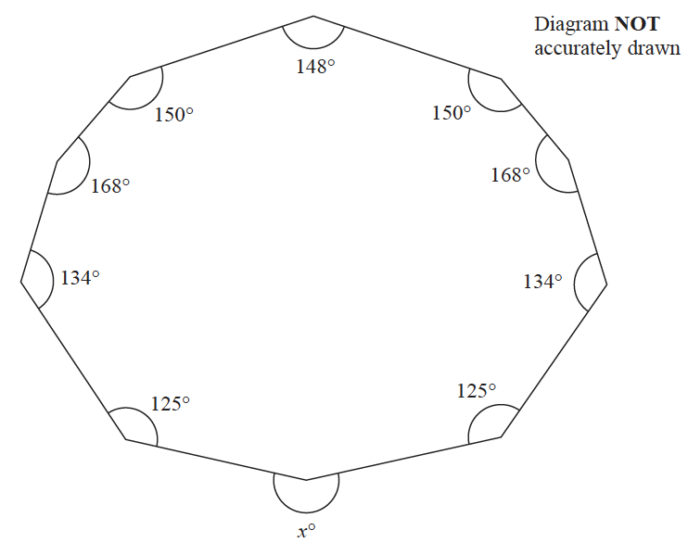

Work out the value of *x*.

*x* = .......................................................

**(Total for Question 8 is 4 marks)**

**___________________________________________________________________________**

**9** A rocket travelled 100 km at an average speed of 28 440 km/h.

Work out how long it took the rocket to travel the 100 km.

Give your answer in seconds, correct to the nearest second.

....................................................... seconds

**(Total for Question 9 is 3 marks)**

**___________________________________________________________________________**

**10** Toy cars are made in a factory.

The toy cars are made for 15 hours each day.

5 toy cars are made every 12 seconds.

For the toy cars made each day, the probability of a toy car being faulty is 0.002

Work out an estimate of the number of faulty toy cars that are made each day.

.......................................................

**(Total for Question 10 is 4 marks)**

**___________________________________________________________________________**

**11**

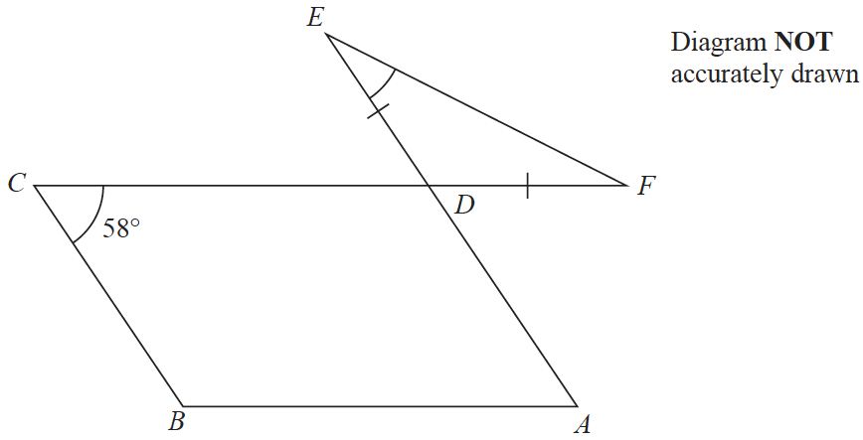

The diagram shows a parallelogram *ABCD* and an isosceles triangle *DEF* in which *DE* = *DF*

*CDF* and *ADE* are straight lines.

Angle *BCD* = 58°

Work out the size of angle *DEF*.

Give a reason for each stage of your working.

.......................................................°

**(Total for Question 11 is 5 marks)**

**___________________________________________________________________________**

**12** The diagram shows trapezium *ABCD* in which *BC* and *AD* are parallel.

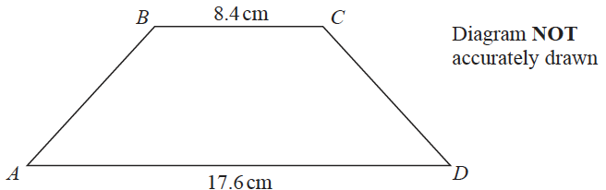

The trapezium has exactly one line of symmetry.

*BC* = 8.4 cm

*AD* = 17.6 cm

The trapezium has area 179.4 cm2

Work out the size of angle *ABC*.

Give your answer correct to 1 decimal place.

.......................................................°

**(Total for Question 12 is 6 marks)**

**___________________________________________________________________________**

**13** The table gives information about the heights, in centimetres, of some plants.

|  |  |
| --- | --- |
| **Height (*h* cm)** | **Frequency** |
| 10 < *h* ≤ 20 | 35 |
| 20 < *h* ≤ 35 | 45 |
| 35 < *h* ≤ 50 | 75 |
| 50 < *h* ≤ 70 | 40 |
| 70 < *h* ≤ 80 | 8 |

(*a*)On the grid, draw a histogram for this information.

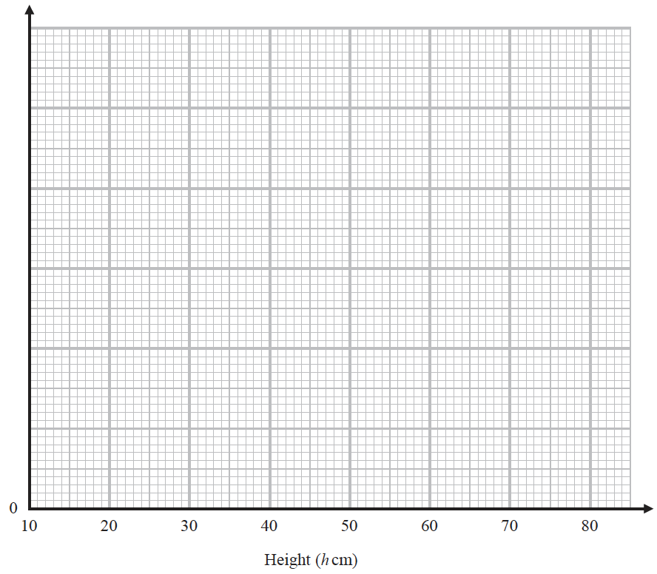

**(3)**

(*b*)Work out an estimate for the number of these plants with a height greater than 40 cm.

.......................................................

**(2)**

**(Total for Question 13 is 5 marks)**

**___________________________________________________________________________**

**14** Jan invests $8000 in a savings account.

The account pays compound interest at a rate of *x* % per year.

At the end of 6 years, there is a total of $8877.62 in the account.

Work out the value of *x*.

Give your answer correct to 2 decimal places.

*x* = .......................................................

**(Total for Question 14 is 3 marks)**

**___________________________________________________________________________**

**15**The diagram shows cuboid *ABCDEFGH*.

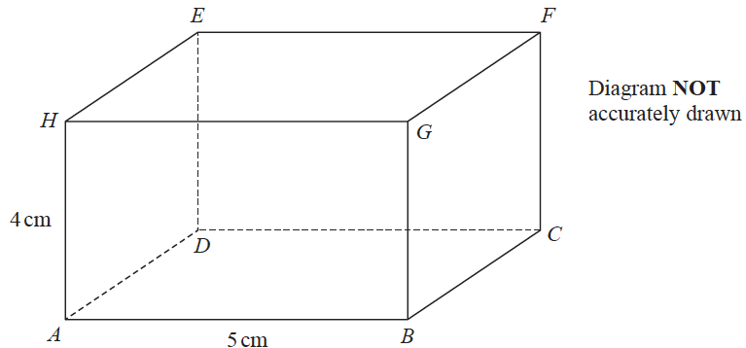

*AB* = 5 cm

*AH* = 4 cm

The size of the angle between *CH* and the plane *ABCD* is 35°

Calculate the volume of the cuboid.

Give your answer correct to 3 significant figures.

.......................................................cm3

**(Total for Question 15 is 5 marks)**

**___________________________________________________________________________**

**16**Andreas, Isla and Paulo share some money in the ratios 3 : 2 : 5

The **total**amount of money that Isla and Paulo receive is £76 more than the amount of

money that Andreas receives.

Andreas buys a video game for £48.50 with some of his share of the money.

Work out how much money Andreas has left from his share of the money when he has

bought the video game.

£.......................................................

**(Total for Question 16 is 4 marks)**

**___________________________________________________________________________**

**17 R** and **S** are two similar solid shapes.

Shape **R** has surface area 108 cm2 and volume 135 cm3

Shape **S** has surface area 300 cm2

Work out the volume of shape **S**.

....................................................... cm3

**(Total for Question 17 is 3 marks)**

**___________________________________________________________________________**

**18** *A* = 2 × 343

*B* = 16 × 337

(*a*)Find the highest common factor (HCF) of *A* and *B*.

.......................................................

**(1)**

(*b*)Express the number *A* × *B* as a product of powers of its prime factors.

Give your answer in its simplest form.

.......................................................

**(2)**

**(Total for Question 18 is 3 marks)**

**___________________________________________________________________________**

**19** *ABCD* is a rhombus.

The diagonals, *AC* and *BD*, intersect at the point *M*. The coordinates of *M* are (6, −11)

The points *A* and *C* both lie on the line with equation 2*y* + 7*x* = 20

Find the exact coordinates of the point where the line through *B* and *D* intersects the *y-*axis.

(............................ , ............................)

**(Total for Question 19 is 4 marks)**

**___________________________________________________________________________**

**20** A metal block has a mass of 5 kg, correct to the nearest 50 grams.

The block has a volume of (1.84 × 10 –3) m3, correct to 3 significant figures.

Work out the upper bound for the density of the block.

Give your answer in kg/m3 correct to 1 decimal place.

Show your working clearly.

....................................................... kg/m3

**(Total for Question 20 is 4 marks)**

**TOTAL FOR PAPER IS 80 MARKS**