**GCSE Mathematics**

**Practice Tests: Set 13**

**Paper 1F (Non-calculator)**

**Time: 1 hour 30 minutes**

You should have: Ruler graduated in centimetres and millimetres, protractor, pair of compasses, pen, HB pencil, eraser, calculator. Tracing paper may be used.

**Instructions**



* Use **black** ink or ball-point pen.
* **Fill in the boxes** at the top of this page with your name,  
  centre number and candidate number.
* Answer **all** questions.
* Answer the questions in the spaces provided

– *there may be more space than you need*.

* **Calculators may not be used.**
* Diagrams are NOT accurately drawn, unless otherwise indicated.
* You must **show all your working out.**

**Information**

* The total mark for this paper is 80
* The marks for **each** question are shown in brackets  
  – *use this as a guide as to how much time to spend on each question*.

**Advice**

* Read each question carefully before you start to answer it.
* Keep an eye on the time.
* Try to answer every question.
* Check your answers if you have time at the end.

**Answer ALL questions.**

**Write your answers in the spaces provided.**

**You must write down all the stages in your working.**

**1** The bar chart gives information about the number of points scored by each of four

teachers in a quiz.

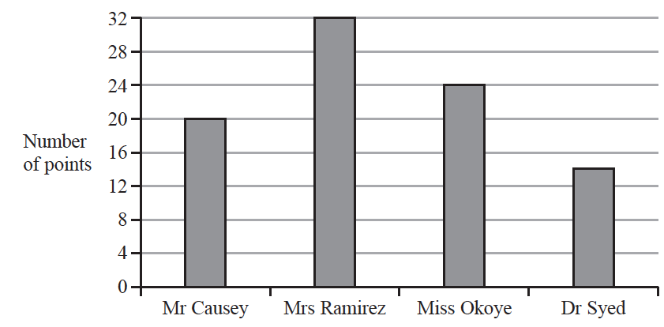

Joseph starts to draw a pictogram, shown below, for this information.

The pictogram shows the number of points scored by Mr Causey and the number of

points scored by Mrs Ramirez.

|  |  |  |  |
| --- | --- | --- | --- |
| Mr Causey |  |  |  |
| Mrs Ramirez |  |  | Key:    represents ............................points |
| Miss Okoye |  |  |
| Dr Syed |  |  |  |

Complete the pictogram, including the key.

**(Total for Question 1 is 4 marks)**

**___________________________________________________________________________**

**2** At 6 p.m., the temperature in Victoria’s garden was 5 °C.

By midnight, the temperature in Victoria’s garden had fallen by 9 °C.

(*a*)Work out the temperature in Victoria’s garden at midnight.

......................................................°C

**(2)**

Here is a list of 7 temperatures.

|  |  |  |  |  |  |  |
| --- | --- | --- | --- | --- | --- | --- |
| 4 °C | −6°C | 4 °C | 0 °C | −1 °C | −7 °C | −5 °C |

(*b*)For the 7 temperatures in the list,

(i) write down the mode,

......................................................°C

**(1)**

(ii) find the median.

......................................................°C

**(2)**

**(Total for Question 2 is 5 marks)**

**___________________________________________________________________________**

**3** Here is a shape made from squares.



(*a*)What fraction of this shape is shaded?

.......................................................

**(1)**

(*b*)Write  as a mixed number.

.......................................................

**(1)**

(*c*)Write 0.23 as a fraction.

.......................................................

**(1)**

(*d*)Write  as a decimal.

.......................................................

**(1)**

(*e*)Write these decimals in order of size.

Start with the smallest decimal.

|  |  |  |  |  |
| --- | --- | --- | --- | --- |
| 3.61 | 3.9 | 3.555 | 3.82 | 3.7 |

.....................................................................................................................................................

**(1)**

**(Total for Question 3 is 5 marks)**

**___________________________________________________________________________**

**4** Paul is buying a sandwich and a drink in a meal deal.

He can have a cheese sandwich (*C*)or an egg sandwich (*E*)or a tomato sandwich (*T*).

He can have orange juice (*O*) or milk (*M*) or water (*W*) to drink.

Write down all the possible combinations Paul can buy.

......................................................................................................................................................

......................................................................................................................................................

......................................................................................................................................................

**(Total for Question 4 is 2 marks)**

**___________________________________________________________________________**

**5**

|  |  |  |  |  |  |
| --- | --- | --- | --- | --- | --- |
|  | 3 | 2 | 6 | 8 |  |

(*a*)Write down the largest possible four digit number using all the digits that are

in the box.

......................................................

**(1)**

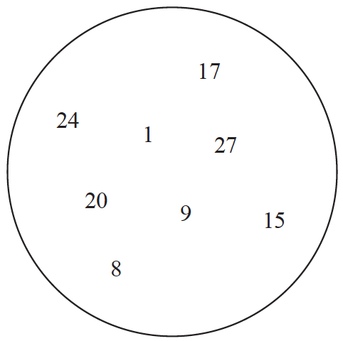

From the numbers in the circle, write down

(*b*)a multiple of 6

......................................................

**(1)**

(*c*)a prime number

......................................................

**(1)**

**(Total for Question 5 is 3 marks)**

**___________________________________________________________________________**

**6** On the grid, draw the graph of *y* = 3*x* + 2 for values of *x* from −2 to 4

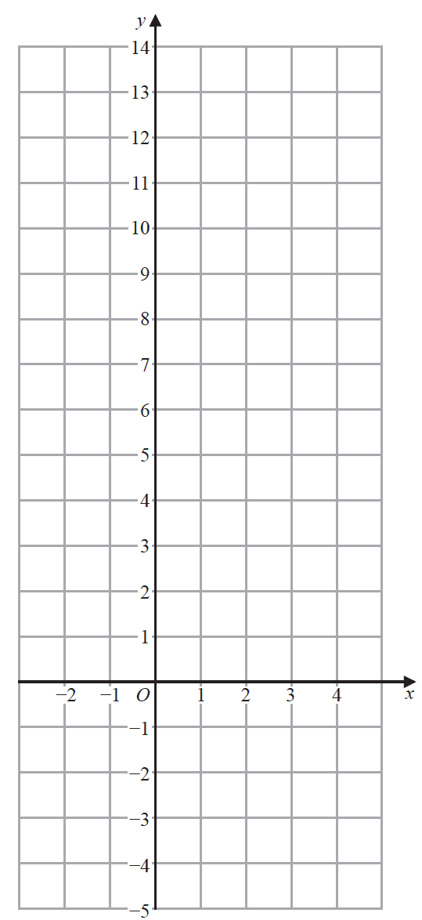

**(Total for Question 6 is 3 marks)**

**__________________________________________________________________________**

**7** (*a*)Simplify 3*r* × 5*t*

......................................................

**(1)**

(*b*)Solve 4*x* + 5 = 27

*x* = ......................................................

**(2)**

*P* = 7*w* – 5*y*

(*c*)Find the value of *P* when *w* = 2 and *y* = 4

*P* = ......................................................

**(2)**

*Q* = 2*u*2 − 5

(*d*)Find the value of *Q* when *u* = −3

*Q* = ......................................................

**(2)**

**(Total for Question 7 is 7 marks)**

**___________________________________________________________________________**

**8** *P*, *Q* and *R* are three points marked on a grid.

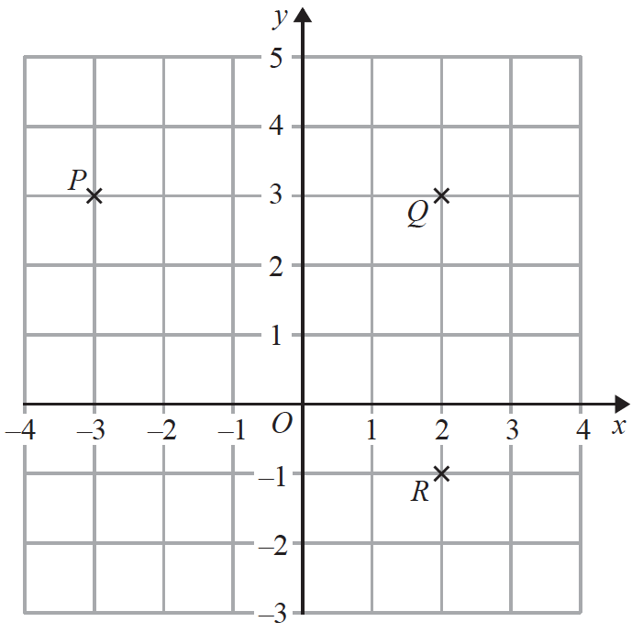

(*a*)Write down the coordinates of point *Q*.

(............................ , ............................)

**(1)**

*S* is the point such that *PQRS* is a rectangle.

(*b*)Find the coordinates of point *S*.

(............................ , ............................)

**(1)**

(*c*)Find the coordinates of the midpoint of *PR*.

(............................ , ............................)

**(2)**

**(Total for Question 8 is 4 marks)**

**___________________________________________________________________________**

**9** (*a*)Write in figures the number **seventy thousand, two hundred and sixteen**.

.......................................................

**(1)**

(*b*)Write down a common factor of 20 and 30

.......................................................

**(1)**

(*c*)Write down a square number that is between 20 and 40

.......................................................

**(1)**

(*d*)Find the cube root of 3375

.......................................................

**(1)**

(*e*)Write brackets in the following calculation so that the answer is correct.

42 – 6 ÷ 6 – 3 = 40

**(1)**

**(Total for Question 9 is 5 marks)**

**___________________________________________________________________________**

**10** (*a*)On the grid below, draw a kite.



**(1)**

(*b*)Write down the mathematical name of an 8-sided polygon.

......................................................

**(1)**

Here is a solid prism.



(*c*)(i) Write down the mathematical name of this prism.

......................................................

(ii) How many vertices does the prism have?

......................................................

**(2)**

**(Total for Question 10 is 4 marks)**

**___________________________________________________________________________**

**11** Egor rolled a dice 24 times.

Here are his results.

|  |  |  |  |  |  |
| --- | --- | --- | --- | --- | --- |
| 2 | 3 | 5 | 4 | 6 | 2 |
| 1 | 3 | 3 | 5 | 1 | 3 |
| 3 | 5 | 5 | 6 | 2 | 5 |
| 4 | 3 | 4 | 3 | 3 | 4 |

(*a*)Complete the frequency table for Egor’s results.

|  |  |  |
| --- | --- | --- |
| **Number on dice** | **Tally** | **Frequency** |
| 1 |  |  |
| 2 |  |  |
| 3 |  |  |
| 4 |  |  |
| 5 |  |  |
| 6 |  |  |

**(2)**

(*b*)Write down the mode of the numbers that Egor rolled.

.......................................................

**(1)**

Egor thinks the dice he rolled is biased.

(*c*)Give a reason why the results could show that the dice is biased.

......................................................................................................................................................

......................................................................................................................................................

......................................................................................................................................................

**(1)**

**(Total for Question 11 is 4 marks)**

**___________________________________________________________________________**

**12** (*a*)Simplify *k* + *k* + *k* + *k*

.......................................................

**(1)**

*f* = 9 × 9 × 9 × 9

(*b*)(i) Write *f* as a single power of 9

.......................................................

(ii) Write *f* as a single power of 3

.......................................................

**(2)**

(*c*)Write 517 × 52 as a single power of 5

.......................................................

**(1)**

(*d*)Write 800 as a product of its prime factors.

Show your working clearly.

.................................................................................

**(2)**

**(Total for Question 12 is 6 marks)**

**__________________________________________________________________________**

**13** (*a*)Make *a* the subject of *d* = *g* + 2*ac*

......................................................

**(2)**

(*b*)Factorise fully 9*e f* − 12 *f*

......................................................

**(2)**

(*c*)Expand and simplify (*x* + 2)(*x* − 5)

......................................................

**(2)**

(*d*)Simplify fully 

......................................................

**(2)**

**(Total for Question 13 is 8 marks)**

**___________________________________________________________________________**

**14** (*a*)Expand *e*(3*e* – 5)

.......................................................

**(1)**

(*b*)Factorise 35 + 5*f*

.......................................................

**(1)**

(*c*)Simplify (4*pq*2)3

.......................................................

**(2)**

**(Total for Question 14 is 4 marks)**

**___________________________________________________________________________**

**15** Write down the integer values of *x* that satisfy the inequality −2 < *x* ≤ 4

..................................................................................

**(Total for Question 15 is 2marks)**

**________________________________________________________________________**

**16**

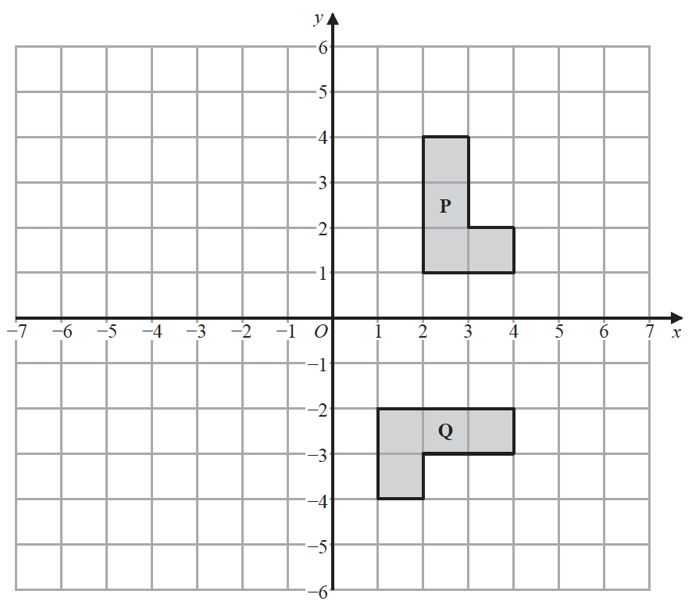

(*a*)Describe fully the single transformation that maps shape **P** onto shape **Q**.

......................................................................................................................................................

......................................................................................................................................................

**(3)**

(*b*)On the grid, reflect shape **P** in the line *x* = −1

Label the new shape **R**.

**(2)**

**(Total for Question 16 is 5 marks)**

**___________________________________________________________________________**

**17** Show that 

**(Total for Question 17 is 3 marks)**

**___________________________________________________________________________**

**18** Solve the simultaneous equations

3*x* + 5*y* = 6

7*x* – 5*y* = −11

Show clear algebraic working.

*x* = .......................................................

*y* = .......................................................

**(Total for Question 18 is 3 marks)**

**___________________________________________________________________________**

**19** Solve *x*2 − 5*x* − 36 = 0

Show clear algebraic working.

......................................................

**(Total for Question 19 is 3 marks)**

**TOTAL FOR PAPER IS 80 MARKS**

**BLANK PAGE**