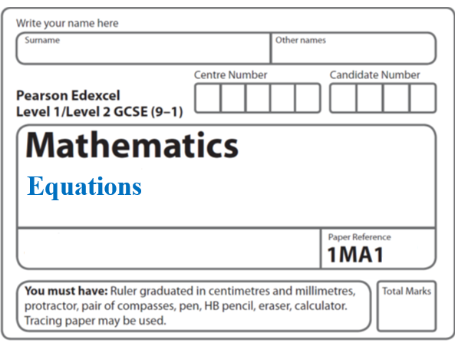**Instructions**

**Solving equations: Linear**

* Use **black** ink or ball-point pen.
  + **Fill in the boxes** at the top of this page with your name,  
    centre number and candidate number.
* Answer **all** questions.
* Answer the questions in the spaces provided  
  *– there may be more space than you need.*
* You must **show all your working.**
* Diagrams are **NOT** accurately drawn, unless otherwise indicated.
* If your calculator does not have a *π* button, take the value of *π* to be3.142

unless the question instructs otherwise.

**Information**

* The total mark for this paper is **14**. There are **4** questions.
* Questions have been arranged in an ascending order of mean difficulty, as found by all students in the June 2017–November 2019 examinations.
* The marks for **each** question are shown in brackets  
  *– use this as a guide as to how much time to spend on each question.*

**Advice**

* Read each question carefully before you start to answer it.
* Keep an eye on the time.
* Try to answer every question.
* Check your answers if you have time at the end.

**1** Solve  = 2*x* – 7

*x* = .......................................................

(**Total for Question 1 is 3 marks**)

**___________________________________________________________________________**

**2** Solve 5*x* – 6 = 3(*x* – 1)

*x* = ......................................................

**(Total for Question 2 is 3 marks)**

**___________________________________________________________________________**

**3** (*a*)Solve  = 11 − *x*

*x* = .......................................................

**(3)**

(*b*)Simplify 

.......................................................

**(1)**

**(Total for Question 3 is 4 marks)**

**4** Solve 

*x* = ......................................................

**(Total for Question 4 is 4 marks)**

**___________________________________________________________________________**

**TOTAL MARKS FOR PAPER: 14**